

***NOVEMBER /DECEMBER 2018 NEWSLETTER***

***Dear Member***

Compliments of the festive season, it has been a very hot summer, the anticipated rains are finally here, what a relief and a blessing indeed for our golf course.

Every corner of the course is now green, what difference from the previous month, however each season has its own effects, please make sure you carry a raincoat or umbrella and to leave the course when the lightning siren is on.



If you are interested in advertisng in the newsletter, contact the Sales and Marketing [marketing@chapmangolf.co.zw](mailto:marketing@chapmangolf.co.zw) or visit us to discuss our advertising packages for the newsletter, billboards and tee boxes they are an ideal platform to advertise your products.

Book for your 2019 Corporate and Fundraising Golf Days now, we are offering **Thursdays and Fridays** there are limited dates left , hurry and book now.

|  |  |  |  |
| --- | --- | --- | --- |
| WEDNESDAY CLUB COMPETITION | | SATURDAY CLUB COMPETITION | |
| DATE | **SPONSOR** | **DATE** | **SPONSOR** |
| 05 December | **Kutaura Enterprises** | 01 December | **CBZ BANK** |
| 12 December | **Please Sponsor this day** | 08 December | **Please sponsor this day** |
| 19 December | **R.Baylis** | 15 December | **Please sponsor this day** |
| 26 December | **Holiday friendly games** | 22 December | **Xmas Bring a prize** |
|  |  | 29 December | **Please sponsor this day** |

We would like to thank all our Club Competition sponsors for your unwavering support under a very difficult environment this year, kindly secure your dates for sponsoring the 2019 Wednesday and Saturday Club Competitions, most of the dates are available now, contact Golf Admin, Ranga and Doug.

Chapman is still the most patronised club and the best platform to advertise your business.

**2018 CHAPMAN ANNUAL PRIZE GIVING DINNER AWARDS.**



**2018 CLUB CHAMPION TAFARA MPOFU Proudly wearing the Champion jacket**

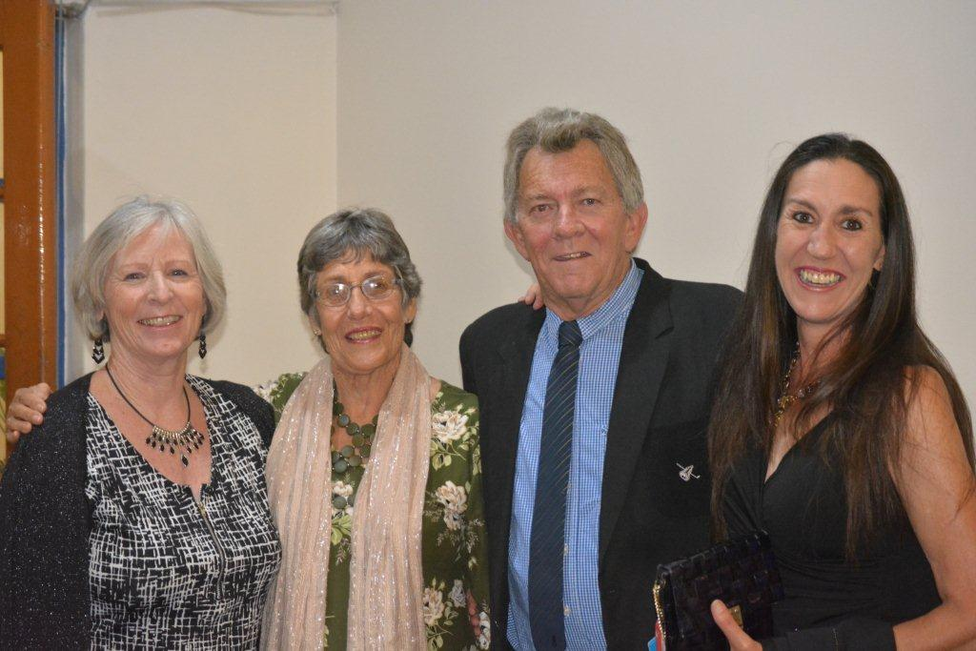

This 2018 Annual Prize Giving Dinner was well attended with over 100 members and guests. We would like to thank everyone for supporting the event.

**New members**

The Club continues to attract new members every month and that is a sign of a bright future for the Chapman. Members are urged to recruit their family members and business friends to join the club.

|  |  |  |  |  |  |  |  |  |  |  |  |  |  |  |  |  |  |  |  |  |  |
| --- | --- | --- | --- | --- | --- | --- | --- | --- | --- | --- | --- | --- | --- | --- | --- | --- | --- | --- | --- | --- | --- |
| |  |  |  | | --- | --- | --- | | Anton Philip Columbus | Wishes Mauwa | Herbert Murombo | | Alistar John Macleod | **Tinashe Makaza** | **Moses Hungwe Chinhengo** | | Shadreck Farirayi | **Bungare Fainah Maidei** | **Gumisai Makoni** | | Kexion Grant-Zimbie | **Cuthbert Maposa** | **Joel Mashava** | | Emmanuel Tapera | **Tinashe Kutama** | **Hazel Makonese** | | Martin Chijara | **Tonderi Tafanayi** | **Gerald Kunsamala** | | Ma Cheng Toan |  |  | |
|  |



Range News:

Please note our Opening and Closing times for the Festive Season.

* Christmas Eve – Opening 7am -Closing 4pm
* Christmas Day – CLOSED
* Boxing Day – Open 10am – Closing 4pm
* New Year’s Eve – Open 7am – Closing 4pm
* New Year’s Day – CLOSED



We would like to wish you all a safe and golf filled Christmas and all the best for 2019!!

Cath Riley

Phone - +263 776088326

WhatsApp - +263 776088326

Email – [jcr@yoafrica.com](mailto:jcr@yoafrica.com)



Ladies Section

Below is the new Ladies committee for 2019;

Lady Captain : Elsa Fuchs

Vice Lady Captain : Pam Massey

Secretary : Ursula Malan

Committee Members : Jean Mckenzie

Gloria Mutekwa

Irene Chikumbo

Heidi Schirmer

Judith Nyariri

Margie Brandt

Karen Thompson

**From the Greens of F2G**

Hello Fellow Members and Golfers

The festive season is upon us as well as the rains.

A few pointers and tips for us all.

1:            Carry protective rain ware, umbrellas as the rains can normally catch you when you are furthest from adequate cover

2:            Take head of lightening and listen out for the siren that indicates suspension of play.

                (Remember once the siren/horn is sounded YOU MUST DISCONTINUE PLAY**. Mark your ball**and seek cover and wait for the siren/horn to signify continuance of play.)

                Your safety is of prime concern to everyone

3:            With the onset of the rains the course is going to get tough, thick grasses, mud and all the related issues.

                We will endeavor to keep the rough playable, the greens smoother and the fairways lush and cut for you to enjoy.

ALL WE ASK of players is to repair your divots, grass regeneration and recovery is faster when filled with nutrient filling.

The pitch marks recover much quicker when the compressed area on the green is loosened and then gently pressed down.

Clean your shoes in the rough if possible before walking on the green it helps prevent foreign seed and undesirables going on the green.

4:            Our equipment hopefully will see us through the wet weather to ensure you a ruff free course

5:            Check your local rules for relief options if any during the wet conditions and

A few tit bits to keep you on track and within the confines of the rules.

**You are probably aware that the current 34 Rules of Golf are being replaced on 1st January 2019 with the new, modernized 24 Rules of Golf.**

**Look up the new rules and familiarize yourself and fellow players with the new changes.**

**These changes have been implemented to help speed up play and be less punitive to players (Within reason)**

**Question 10:**

Due to very wet course conditions a temporary Local Rule has been introduced, permitting players to mark and place their ball within the length of their score card (six inches), if their ball lies on a closely mown area through the green. Roz Russ knocks down her drive but it comes to rest on the closely mown walkway through the area of rough from the teeing ground to the fairway. She marks and picks-up her ball, cleans it and replaces it almost a club-length from where she picked it up. She plays a good shot to the right side of the fairway and again marks, lifts and cleans her ball, placing it almost a club-length from where it was at rest. She plays her next shot onto the putting green and sinks the putt. What is Roz's score for the hole?

*(The answer is below)*

**19th Hole Titbit - Do You Know?**

That you may place a club, or even a trolley containing a bag of clubs, in a bunker without penalty (but don't do the latter!). Exception 1(b) to Rule 13-4.

**Answer 10:**  
1 - Drive from tee.  
2 - Stroke from walkway to fairway.  
3 & 4 - Two penalty strokes for replacing her ball outside the distance permitted by the temporary Local Rule.  
5 - Stroke from fairway to putting green.  
6 & 7 - Two more penalty strokes for replacing her ball outside the distance permitted by the temporary Local Rule.  
8 - Putt into hole.  
Note: It is important to read the Local Rules before commencing play as they vary from course to course. Breach of a Local Rule incurs the general penalty of two strokes.

Roz’s scores 8 for the hole.

On the lighter side herewith our “True Story”

Toronga and Mike were two of the most bitter rivals at the club. Neither man trusted the other’s arithmetic. One day they were playing a heated match and watching each other like hawks.

After holing out on the fourth green and marking his six on the scorecard, Mike asked Toronga,”What’d you have?

Toronga went through the motions of mentally counting up.

“Six!” he said and then hastily corrected himself. “No, no… a five.”

Calmly, Mike marked the scorecard, saying out loud “Eight!”

“Eight?” Toronga said, “I couldn’t have had eight.”

“Nope, you claimed six, then changed it to five, but actually you had seven,” John explained.

“Then why did you mark down eight?” asked Toronga.

Mike told him, “One stroke penalty for improving your lie.”

That’s all from the Greens 2 Fairways Team

In closing may we wish all members, friends, fellow golfers and their families a safe and festive holiday season and a better swing in 2019.

Enjoy responsibly and see you all in New Year happy Golfing.

**INTERNAL RESULTS**

Monthly Medal (November) – Sponsored By CBZ Holdings

D Division 19-24 h/caps

Runner up Godfrey Kaitano h/c 24 nett 72  
Winner Dean Brandt h/c 22 nett 66

C Division 13-18 h/caps

Runner Up Alfred Murumbi h/c 14 net 71 c/out Dzikiti S  
Winner Francis Macheka h/c 16 nett 70

B Division 7-12 h/caps

Runner Up Darican Tsangamwe h/c 11 nett 71  
Winner Tariro November h/c 10 nett 70

Championship Division 0-6 h/caps

Runner up R Mohamed h/c +1 nett 72  
Winner Keegan Shutt h/c 6 nett 71

Monthly Medal (December) – Sponsored By CBZ Holdings

D Division 19-24 h/caps

Runner up G Kaitano h/c 21 nett 77  
Winner O Manetu h/c 19 nett 74

C Division 13-18 h/caps

Runner Up R Nhau h/c 15 nett 73  
Winner A Toronga h/c 13 nett 69

B Division 7-12 h/caps

Runner Up N Dube h/c 10 nett 75  
Winner R Vas h/c 9 nett 70

Championship Division 0-6 h/caps

Runner up M Masvimbo h/c 5 nett 74  
Winner R Mohamed h/c +1 nett 72

**EXTERNAL RESULTS .**

Chapman ‘B’ League team won the 2018 Harare Province Golf Union Championships and the ‘A’ League team came third. Well done guys you made us proud. Keep the Chapman flag flying high and all the best for 2019.



**2018 HPGU ‘B’ LEAGUE CHAMPIONS**

**Please Note;**

If you wish to represent the Club in the ‘A’ and ‘B’ Leagues games contact the following League Captains: E Chakanyuka, [**e*dchak@hotmail.com***](mailto:edchak@hotmail.com%20%20%20%20%20&) & Chips De Oliveira, [***chips@alpha.co.zw***](mailto:chips@alpha.co.zw)

**IMPORTANT MESSAGES**

* Members are reminded that **Subscription Fees Are Prepaid** for every quarter not at the end of the term, Members who are in arrears will not be permitted to play until they are in good standing with the Club. ZGA/ZLGU affiliation fees should be paid on the 1st quarter of every year to enable you to have a handicap.
* Please update your contact details with club always, if you are not receiving any mail or notifications from the club then your contact details are not correct.
* Visit our website on [www.chapmangolf.co.zw](http://www.chapmangolf.co.zw) to view your handicaps, forthcoming events, recent results and much more information about your club. The gallery is full of club events pictures.
* Members are reminded to handle club property with care i.e. changing rooms’ equipment, towels, showers, sauna and any other club property that you make use of.
* Players are urged to look after their valuables when they are at the Club,
* They must not leave their car windows and doors open, please close and lock them.
* They must lock away their valuables e.g. jewellery, cash, cell phones etc. and not to leave in their bags in the changing rooms.
* They must check for all their Golf Clubs with their caddies after playing and before leaving the club.
* Please note lockers are Club property for rental at **$40.00** per annum or $2 per day.
* Let us keep our Club House and Golf Course environments clean by placing litter in the bins that are provided on the course and around the Club house.
* Take Care and Drive Carefully This Holiday.

*We Wish You a Merry Christmas and a Happy Year New*

**TABETH ZVIDZWA**

*SALES AND MARKETING*