

***March NEWSLETTER 2018***

***Dear Member,***

With the rains gone in the month of March and slowly drifting out of summer time am sure there is no excuse for us to come out and have a nice round of Golf. The greens are well manicured giving a bit of challenge to those that haven’t played in while at the best Club in town, “Chapman we do the best for any golfer”.

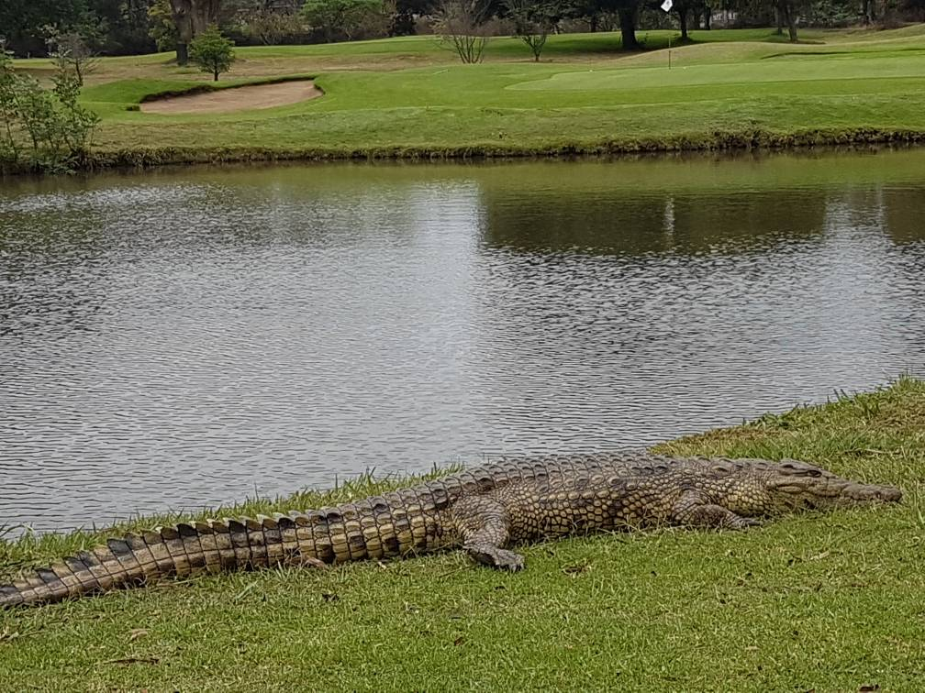

The crocodile sun bathing on the 11th Dam

Our Wednesday and Saturday club competitions need your full support. Sponsor one competition day for only $250.00 worth of prices. We are open every day of the month and our services range from practice range facilities, business lunch, corporate functions and any event you may want us to host for you.

**SPONSORSHIP**

|  |  |  |  |
| --- | --- | --- | --- |
| WEDNESDAY CLUB COMPETITION | | SATURDAY CLUB COMPETITION | |
| DATE | **SPONSOR** | **DATE** | **SPONSOR** |
| 04 April | **Please sponsor this day** | 07 April | **CBZ Holdings** |
| 11 April | **Please sponsor this day** | 14 April | **Please sponsor this day** |
| 18 April | **Please sponsor this day** | 21 April | **Please sponsor this day** |
| 25 April | **Please sponsor this day** | 28 April | **Please sponsor this day** |
|  |  |  |  |





**Captain’s note**

It is a great privilege as well as a huge responsibility to be the Captain of such a remarkable club as Chapman Golf Club. Many thanks go to the Board of Management, management, staff and our prized members for giving me such an opportunity. A special thanks to the Immediate Past Captain, Mr. S. Sibanda, for the wonderful job he and his committees did during his tenure and the mentoring he unreservedly offered to us.

Our committees are all in place and ready to go. There is a blend of experience and skill which we hope to benefit from. A special welcome the new committee members and a heartfelt appreciation to those who have retired. You ran your race and served well.

I would like to cordially invite all members to be proud of everything about Chapman. Everything! Let us all be proud of our brand. And most importantly lets us be proud of our course. Proud Chapman members repair divots, attend to pitch marks, smoothen bunkers and responsibly dispose litter, at the very least.

We would like to appreciate all our proud sponsors for the sterling support which they continuously offer to the club. By sponsoring a Wednesday or Saturday club tournament, one has the opportunity to market their products/services and arrange the prize-table to their taste. Proud members show their courtesy by attending prize giving in support of our esteemed sponsors.

We look forward to another exciting year. Our Club Championships are around the corner, enjoy the preparations. Happy golfing.

*Proudly Chapman*

Justice Udzembwe

**Club Captain**

**The Annual General Meeting**

The Annual General Meeting was held on the 26th of May with more 60 members in attendance . the meeting went on very well

The Following member joined us this year and let us make them feel at home

|  |  |  |  |  |  |  |  |  |  |  |  |  |
| --- | --- | --- | --- | --- | --- | --- | --- | --- | --- | --- | --- | --- |
| |  |  |  | | --- | --- | --- | | Rosina Munthumbira | Mikael Johansson | TsungaiKadenhe | | MlamboGarikai | Vivian Mandizvidza | RinosMautsa | | LawarenceKwendambairi | Sheila Matinya | Lisa Burbidge | | TendayiKanjanda | Davison Norupiri | Boniface Denenge | |
|  |

**EXTERNAL RESULTS March Games**

A League Chapman won 6/0 against, B/Brooke

B League Chapman won 6/0 against, Mt Pleasant

Well done to our teams, they keep on raising the Chapman Flag up high. Well done!!! Well done!!!

**Next Fixtures April Games**

**A League** Chapman vs Ruwa @ Warren

**B League** Chapman vs Ruwa @ Wingate

All games will be played on the 29th of April 2018

PleaseNote; If you wish to represent the Club in the ‘A’ and ‘B’ Leagues games contact the following League Captains: E Chakanyuka[**e*dchak@hotmail.com*** &](mailto:edchak@hotmail.com%20&) Chips De Oliveira[***chips@alpha.co.zw***](mailto:chips@alpha.co.zw)



**MONTHLY MEDAL SPONSORED BY CBZ BANK**

Our CBZ Sponsored Monthly Medal Competitions will this year be played according to handicap order, members are urged to enter their names at Golf Admin if they wish to play. There will be a booking sheet at Golf Admin Notice Board or Call Golf Admin for assistance.

The draw will be done on Thursday prior to the Saturday Competition. No Entries will be entertained after the draw.

**Championship Division 0-6 h/caps**

Runner Up: Tafara Mpofu h/c 0 nett 72

Winner: David Amm h/c 0 nett 71

**Division B 7-12 h/caps**

Runner Up: Rob Vas h/c 9 nett 76

Winner : I Mukudu h/c 11 nett 75

**Division C 13-18 h/caps**

Runner Up: L Murahwa h/c 16 nett 82

Winner: F Muzvondiwa h/c 14 nett 79

**Division D 19-24 h/caps**

Runner Up: S Matsvayi h/c 21 nett 75 c/out N Dube

Winner: V Ranchod h/c 19 nett 72

**IMPORTANT MESSAGES**

* We have advertising opportunities on offer for corporate organisations on the scoreboards, tee box and billboards in and around the golf course. For more information kindly contact the[reception@chapmangolf.co.zw](mailto:reception@chapmangolf.co.zw) or [marketing@chapmangolf.co.zw](mailto:marketing@chapmangolf.co.zw) .
* **Corporate organisations are invited to advertise on our New website. $150.00 per year or $30.00 per month. Visit our website on** [**www.chapmangolf.co.zw**](http://www.chapmangolf.co.zw) **to view your handicap, fourth coming events, recent results and much more.**
* Members are reminded to handle club property with care i.e. changing rooms’ equipment, towels, showers, sauna and any other club property you make use of.
* Players are urged to look after their valuables when they are at the Club,
* They must not leave their car windows and doors open, please close and lock them.
* They must lock away their valuables eg jewellery, cash, cell phones etc in the changing rooms
* They must check for all their Golf Clubs with their caddies after playing and before leaving the premises.
* Please note lockers are Club property for rental at **$40.00** per annum.
* Members are urged to update their email addresses for them to receive important club updates.
* We have reservedcell phone numbers **078 4014414** for accounts office and for the reception **0718 194 081** for members ‘incoming calls only.
* Let us keep our Club environment clean by placing litter in the bins provided on the course and around the Club house.

. Compiled by:

**TABETH ZVIDZWA**

*SALES AND MARKETING*